./

Learning Report – SMART PEN

Course Code: <CODE>



|  |  |  |  |  |  |
| --- | --- | --- | --- | --- | --- |
| **Ver. Rel. No.** | **Release Date** | **Prepared. By** | **Reviewed By** | **Approved By** | **Remarks/Revision Details** |
| 1 | 19/09/2020 | RAJINI R |  |  |  |
|  |  |  |  |  |  |
|  |  |  |  |  |  |
|  |  |  |  |  |  |
|  |  |  |  |  |  |

**Document History**

# 

# REQUIREMENTS

**SMART PEN**

**Aging**

A **pen** is a common [writing instrument](https://en.wikipedia.org/wiki/Writing_tool) used to apply [ink](https://en.wikipedia.org/wiki/Ink) to a surface, usually paper, for writing or [drawing](https://en.wikipedia.org/wiki/Drawing). These pens are used from past around in 4th Century. Initially their was a [reed pens](https://en.wikipedia.org/wiki/Reed_pen), [quill](https://en.wikipedia.org/wiki/Quill) pens, and [dip pens](https://en.wikipedia.org/wiki/Dip_pen) ,which are used only for writing purpose. The reed pen worked by dipping the reed into the ink and it would retain some ink in a split at the point. The ballpoint pen works by using a small rotating ball made of brass, steel, or tungsten carbide to disperse ink as you write. Everything is based on recording information, so we can use it at a later time. Also, today we use comfortable grips so it’s not so hard on our hands.

The types of pens can be categorized as

* A [ballpoint pen](https://en.wikipedia.org/wiki/Ballpoint_pen) dispenses an oil-based ink by rolling a [small hard sphere](https://en.wikipedia.org/wiki/Ball_bearing)
* A [rollerball pen](https://en.wikipedia.org/wiki/Rollerball_pen) dispenses a water-based liquid or [gel](https://en.wikipedia.org/wiki/Gel_pen) ink through a ball tip similar to that of a ballpoint pen
* A [fountain pen](https://en.wikipedia.org/wiki/Fountain_pen) uses water-based liquid ink delivered through a *nib*. The ink flows from a reservoir through a "feed" to the nib, then through the nib, due to [capillary action](https://en.wikipedia.org/wiki/Capillary_action) and gravity.
* A [gel pen](https://en.wikipedia.org/wiki/Gel_pen) uses ink in which [pigment](https://en.wikipedia.org/wiki/Pigment) is [suspended](https://en.wikipedia.org/wiki/Suspension_(chemistry)) in a [water](https://en.wikipedia.org/wiki/Water)-based [gel](https://en.wikipedia.org/wiki/Gel)

As the technology evolved the pens are used for many other purpose such as for taking pictures, GPS tracking, LED lights ,Different ink color ,music system.

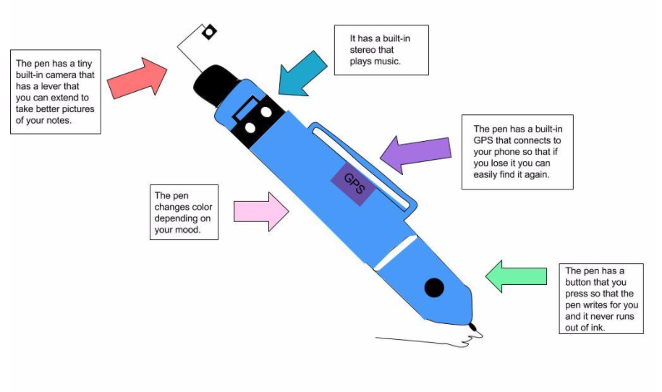

**Figure 9 Features of pen**

**Cost**

|  |  |
| --- | --- |
| **Pen** | **Cost** |
| [Ballpoint pen](https://en.wikipedia.org/wiki/Ballpoint_pen) | Ranges between Rs 5/- to Rs 100/- |
| [Rollerball pen](https://en.wikipedia.org/wiki/Rollerball_pen)(Perker pen) | Ranges between Rs 90/- to Rs 1500/- |
| [Fountain pen](https://en.wikipedia.org/wiki/Fountain_pen) | Ranges between Rs 200/- to Rs 500/- |
| [Gel pen](https://en.wikipedia.org/wiki/Gel_pen) | Ranges between Rs 200/- to Rs 300/- |
| Pen with camera,gps tracking,light and music system | Ranges between Rs 1000/- to Rs 4000/- |

The cost of the pens depends on the type of the ink being used and consumption of ink while writing.It also depends on the brand of the pen for example PARKER pen etc.Most these pens are used only for writing purpose,but as the technology evolved along with writing there are many other task that a pen can do.Depending on the feature the cost of the pen will increase.

**Proposed Work**

The purpose or function of the pen is a writing tool. It is still used to write letters, record history, make lists, etc. The computer and phone has taken over many functions of the pen, but is still used and sold worldwide.In this product we are trying to implement a small calculator within the pen.This calculator performs the basic operation of mathematics such as add, sub, multiply, divide, factorial, etc.This pen takes 2 operand from the user through rotating keypad on the pen and there is a separate number system on pen which is used to select which mathematical operation the user needs to perform. The user can enter only integer values and of 4 digits only.Hence this pen can be used for writing as well as for calculation purpose when needed in real time. It is portable and user friendly.

**Requirements**

**High Level Requirements**

|  |  |
| --- | --- |
| **ID** | **DESCRIPTION** |
| HL_01 | Pen size - The '**pen**' part is 5 inches the **pen** and cap are just over 6.5 inches |
| HL_02 | Keypad size-1.5inch rotatable keypad (0-9) |
| HL_03 | Display size – 1.5inch |
| HL_04 | Capillary size of ink should be small and it should be rreplaceble. |

**Low level Requirements**

|  |  |
| --- | --- |
| **ID** | **DESCRIPTION** |
| LL_01 | Numeric value should be of Integer type |
| LL_02 | When user press Top of the pen the input is fed to the software. |
| LL_03 | User can enter only 4 digits |
| LL_04 | Separate numeric column for selecting the operation. |
| LL_05 | Flow of ink should be smooth and can be replaced with any coloured ink. |